PROGRESS REPORT
Agentic AI System for Automotive Spare Parts Management
Document Agent — Design and Progress

Prepared by | Mohnish Bhandarkar — Final Year B.Tech
Status | Document Agent complete | Vision Agent next
Date | July 2026

1. Abstract
This report covers the design and progress of the Document Agent, the first completed module of a multi-agent AI system for automotive spare parts management. The full system is meant to take a request like “I need all parts for the steering assembly of a Mahindra Thar” and handle it end-to-end: read the catalogue, extract the parts list, check stock, and generate a report.
The Document Agent handles the first step: turning a PDF spare-parts catalogue into a clean, structured Bill of Materials (BOM), saved as a JSON file. It is built as an eight-step LangGraph workflow that combines PDF parsing and page search with an LLM for the final extraction, validated with Pydantic before being saved.
The agent has been tested on four real catalogues: Apollo Tractors (wheel drive), Mahindra Scorpio (hand brake), Mahindra Thar (steering gear and mountings), and Tata Indica (intake and exhaust valve). This report explains the architecture, each step of the workflow, the retrieval logic, the prompt design, the output schema, testing, results, limitations, and the plan for the next milestone — the Vision Agent.

2. Problem Statement
Service centres and dealerships regularly request spare parts for repairs. A spare parts factory holds inventory across hundreds of assemblies, but today, matching a request to the right parts is mostly manual.
Assembly information lives inside PDF catalogues, not in any structured database. When a request comes in, someone has to open the right catalogue, find the right section (which can span several pages and sit next to unrelated assemblies), read a table, and manually check it against inventory. This is slow and does not scale as more catalogues and vehicle models are added.
This project asks: can an AI system do this extraction and matching automatically, without a person manually reading every catalogue page?

3. Objectives
The overall project builds a multi-agent system that reads catalogues, understands exploded-view diagrams, checks a mock inventory database, flags shortages, and produces a report. The objectives covered by this report, for the Document Agent, are:
- Load and index any PDF spare-parts catalogue.
- Find the pages relevant to a plain-language assembly query, without page numbers being given.
- Extract both text and tables from the relevant pages.
- Convert the extracted content into a clean, structured BOM using an LLM guided by a clear prompt.
- Validate the output against a schema before saving it.
- Save the result as a predictable JSON file that later agents can use.
- Test the approach across catalogues from different manufacturers with different layouts.

4. Overall Multi-Agent Architecture
The full system is designed as a pipeline of five agents, each with one job. This is similar to how a team would split the same task: one person reads the brochure, one reads the diagram, one checks the warehouse, one decides what is short, and one writes the report.
Figure 1: Five-agent pipeline. The Document Agent is complete; the Vision Agent is the next milestone.
Agent | Responsibility | Status
Document Agent | Parse PDF catalogues and extract a structured BOM for the requested assembly | Complete (this report)
Vision Agent | Read exploded-view diagrams using a multimodal model to identify parts and part numbers | Next milestone
Inventory Agent | Query a mock inventory database and return stock levels for each part | Planned
Decision Agent | Compare the BOM against stock and flag parts that are unavailable or low | Planned
Report Agent | Produce a readable fulfilment report for the service centre | Planned

Since only the Document Agent is built and tested so far, the rest of this report focuses on it. Its output (a validated BOM JSON file) is what the Inventory Agent will read once it is built.

5. LangGraph Workflow — Document Agent
The Document Agent is built as a linear StateGraph using LangGraph. LangGraph was chosen because it keeps the pipeline's state explicit at every step and lets the graph be visualised directly from the code, without drawing it by hand.
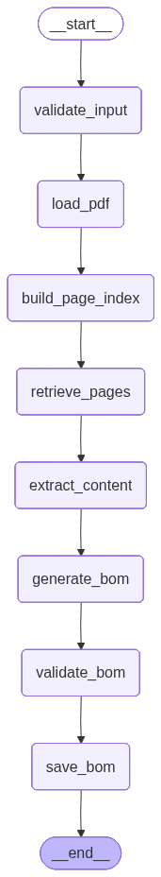
Figure 2: Workflow graph generated directly from the running code (agents.document.main), showing the eight steps in order.
The graph is defined in graph.py by registering eight nodes on a StateGraph typed to DocumentState, then connecting them in order, starting at validate_input and ending at save_bom. Each node receives the shared state, updates the relevant fields, and passes it to the next node.
workflow = StateGraph(DocumentState)
workflow.add_node("validate_input", validate_input)
workflow.add_node("load_pdf", load_pdf)
workflow.add_node("build_page_index", build_page_index)
workflow.add_node("retrieve_pages", retrieve_relevant_pages)
workflow.add_node("extract_content", extract_relevant_content)
workflow.add_node("generate_bom", generate_bom)
workflow.add_node("validate_bom", validate_bom)
workflow.add_node("save_bom", save_bom)
workflow.set_entry_point("validate_input")
# edges chain each node to the next, ending at END
The DocumentAgent class (agent.py) builds this graph once, and exposes a single invoke(pdf_path, query) method. It sets up the starting DocumentState with empty values for every field the graph will fill in, so each node can assume every key already exists.

6. DocumentState — The Shared State
DocumentState (state.py) is a TypedDict that defines the single object passed through every node. Using a typed dictionary rather than a plain dict makes the contract between nodes clear and easy to follow.
Field | Type | Set By | Purpose
pdf_path | str | Caller (invoke) | File path of the source catalogue
user_query | str | Caller (invoke) | Plain-language assembly request, e.g. “WHEEL DRIVE”
assembly_name | str | Reserved | Reserved for future use
pdf_document | Any | load_pdf | In-memory PyMuPDF document handle
page_index | Dict[int, str] | build_page_index | Page number → extracted text
relevant_pages | List[int] | retrieve_relevant_pages | Pages selected as relevant to the query
extracted_text | str | extract_relevant_content | Combined text of the relevant pages
extracted_tables | List[Dict] | extract_relevant_content | Tables found by pdfplumber
bom | Dict[str, Any] | generate_bom / validate_bom | Structured BOM, before and after validation
output_file | str | save_bom | Path of the saved BOM JSON file
status | str | Every node | Current pipeline stage, used for tracking progress
error | str | Any node on failure | Error message if a step fails

The status field acts as a simple trace: it is updated at the end of every node ("validated", "pdf_loaded", "page_index_created", "pages_retrieved", "content_extracted", "bom_generated", "completed", "saved"), so the exact stage reached can always be read from the final state. This is useful for spotting where a run failed.

7. Step-by-Step Explanation

7.1 validate_input
The first step checks three things before any real work starts: that the given pdf_path exists, that it ends in .pdf, and that the user_query is not empty. If any check fails, status is set to "failed" with a clear error message. This keeps every later step free of repeated checks.

7.2 load_pdf
This step opens the catalogue using PyMuPDF (imported as fitz) and stores the document handle in state["pdf_document"]. PyMuPDF was chosen because it is fast at reading pages in bulk, which matters for catalogues with hundreds of pages. Any failure to open the file is caught and reported.

7.3 build_page_index
Once the document is open, this step goes through every page once, extracts its text with PyMuPDF, and builds a dictionary mapping page number to text — state["page_index"]. Doing this once up front means the next step can search the whole catalogue in memory instead of re-reading the file for every page.

7.4 retrieve_relevant_pages
This step finds which pages match the query, since catalogues do not have a machine-readable index. It uses three stages, moving to the next one only if the previous stage finds nothing:
- Exact phrase match — the query is searched for as a literal phrase on each page. Pages under 100 characters are skipped (covers, blank pages). If more than one page matches, the lowest page number is dropped, since it is usually the catalogue's contents page rather than the actual section.
- Keyword scoring — if no exact match is found, each page is scored: +20 if the full query appears anywhere, plus 5 points per occurrence of each query word. The top 5 pages by score are used. This handles cases where the exact phrase is broken up or worded slightly differently.
- Fuzzy matching — as a last resort, each query word is compared against the words on each page using a similarity check (difflib, cutoff 0.80), to catch minor spelling or scanning differences. The top 5 pages are used.
If none of the three stages find a match, the step sets status to "failed" with a clear “No pages found” error, rather than returning an empty or wrong result. This makes failures visible instead of silent.

7.5 extract_relevant_content
With the relevant pages known, this step reopens the PDF using pdfplumber, which is better at reading table structure than PyMuPDF. For each relevant page it pulls out plain text and any tables, combining the text and collecting all table rows into state["extracted_tables"]. Using PyMuPDF for fast full-document indexing and pdfplumber for accurate tables on a small set of pages keeps the pipeline both fast and accurate.

7.6 generate_bom
This is where the extracted content is handed to the LLM. The text is first cleaned by clean_text(), which removes stray characters (pipes, asterisks, extra parentheses), collapses repeated spaces, and expands a small set of known abbreviations (“ASSY” → “ASSEMBLY”, “COLUM” → “COLUMN”, “TIE RODEND” → “TIE ROD END”). The cleaned text, the extracted tables, and the user's query are combined with DOCUMENT_BOM_PROMPT (Section 9) and sent to the LLM in one call. The reply is parsed directly as JSON into state["bom"]. The LLM client is set up once in llm.py using LangChain's ChatOpenAI wrapper, with temperature=0 to keep results consistent across runs.

7.7 validate_bom
The JSON from the LLM is not trusted blindly. This step first converts every part's item field to a string (the LLM can return item numbers as either text or numbers, especially for values like “2-1”), then checks the whole result against the BOM schema using Pydantic (Section 10). If a required field is missing or the wrong type, Pydantic raises an error immediately, turning a hidden data problem into a clear, early failure. On success, status is set to "completed".

7.8 save_bom
The final step saves the validated BOM as a JSON file in an output/ folder (created if it doesn't exist). The filename combines the catalogue name and the query, for example APOLLO_TRACTORS_wheel_drive.json, so repeated runs are easy to find. The file is saved with indent=4 for readability, and state["output_file"] records the path. This JSON file is the final deliverable of the Document Agent and is what the Inventory Agent will read next.

8. Retrieval Logic — Why This Approach
Page retrieval was built as a cascade of increasingly loose text-matching stages rather than a single semantic search, for two reasons. First, catalogue section titles are usually printed almost exactly as a technician would type them, so exact and keyword matching alone resolves most real queries, with no extra setup cost. Second, a semantic search is more likely to pick a similar-sounding but wrong section (for example “FRONT AXLE” vs “REAR AXLE”), while literal matching fails clearly instead of quietly returning the wrong assembly.
The fuzzy-matching fallback exists to handle small text variations that plain matching would miss. A similarity cutoff of 0.80 was chosen as a balance: tight enough to avoid matching unrelated words, loose enough to still catch small differences.
TOP_K (set to 5) limits how many pages move on to extraction and the LLM step, which keeps the cost and speed of generate_bom predictable regardless of catalogue size.

9. Prompt Design — DOCUMENT_BOM_PROMPT
The extraction prompt (prompts.py) has the biggest effect on output quality, since it is the main way the LLM's behaviour is controlled. It is written as a list of clear rules rather than a short instruction, because early tests showed that short prompts led to merged rows, renumbered items, or missing part numbers. The rules are grouped as follows:
- General rules — use only the supplied content, never guess missing information, return JSON only, no extra text.
- Table rules — one row is one part; never merge or split rows; keep row order; extract only the assembly matching the query, and stop as soon as a different assembly title appears.
- Item number rules — copy item numbers exactly as printed, including values like “2-1” or “11-2”, without renumbering.
- Part number rules — copy part numbers exactly; never guess missing digits.
- Description rules — clean up stray characters and extra spaces, expand a fixed set of abbreviations (ASSY, COL, LH, RH), but do not change real technical terms.
- Column-handling rules — do not add extra column values (like effectivity codes) into the description.
- Quantity rules — quantity must always be a whole number; if unreadable, use 0; codes such as “RF” go into remarks, not into quantity.
- Remarks rules — move qualifiers such as TYPE1/TYPE2, W/ABS, N/ABS, LH, RH, RF into remarks, not into the description.
- Ignore rules — skip page numbers, headers, footers, watermarks, figure borders, company names, and repeated titles.
The prompt ends with the exact JSON shape expected, matching the Pydantic models in Section 10, which helps the LLM stick to the right field names and types. temperature=0 is used on the LLM call so results stay consistent across repeated runs.

10. Pydantic Schemas
schemas.py defines two models that the validate_bom step checks the output against. Pydantic gives clear validation errors and one place where the output shape is defined, which both the prompt and later agents can be built around.
class BOMItem(BaseModel):
item: str # Item number shown in catalogue
part_number: str # Manufacturer part number
description: str # Part description
quantity: int = 0 # Quantity required
remarks: str = "" # Additional notes if available

class BOM(BaseModel):
assembly: str
catalogue: str
total_parts: int
parts: List[BOMItem]
Every BOMItem requires item, part_number, and description, since a row missing any of these is not usable. quantity and remarks default to 0 and an empty string, matching how the prompt handles unreadable or missing values. The outer BOM model adds the assembly name, catalogue name, and total part count, so later agents know exactly which assembly and catalogue a BOM came from.

11. Example of a Successful Extraction
This section walks through one full run of the Document Agent, from source catalogue to saved JSON output, using the Tata Indica “Intake and Exhaust Valve” assembly as the example.

11.1 Source catalogue page
The original catalogue page shows the exploded-view diagram for the assembly, with each part numbered 1 to 10.
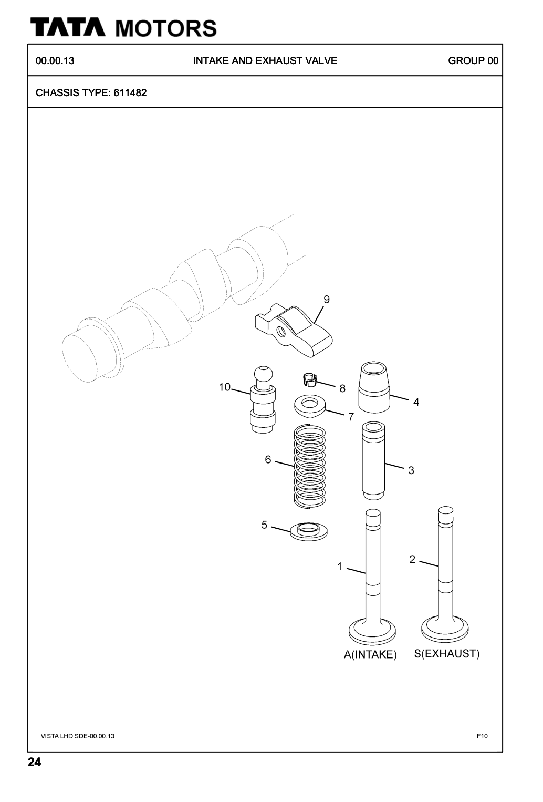
Figure 3: Source exploded-view diagram — Tata Indica, Intake and Exhaust Valve (chassis type 611482).

11.2 Source catalogue table
The same page includes the printed parts table that the Document Agent reads and extracts from.
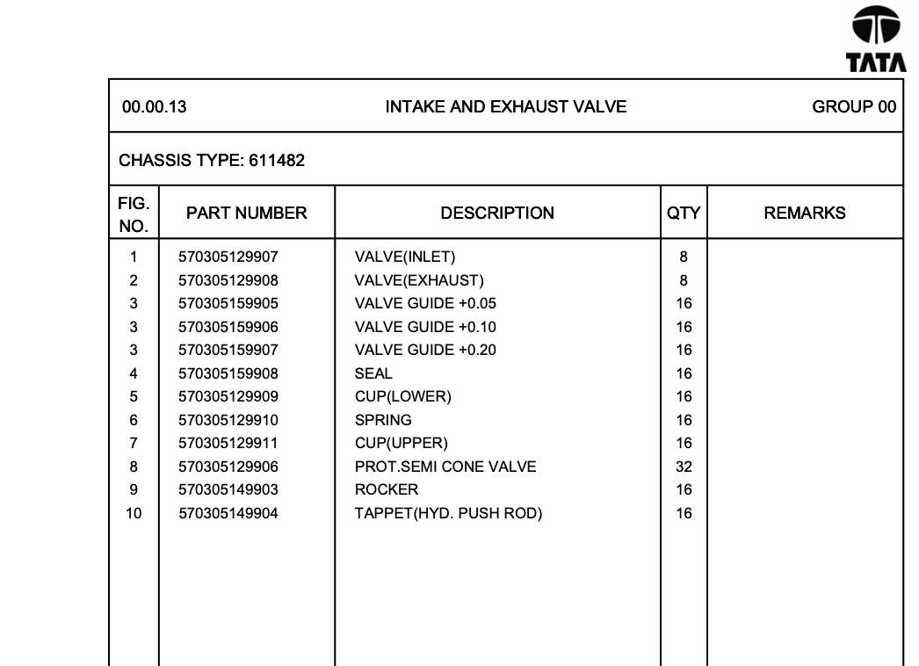
Figure 4: Source parts table for the Intake and Exhaust Valve assembly.

11.3 Agent run and output
Running the agent (python -m agents.document.main) against this catalogue with the query “intake and exhaust valve” produces an exact page match, then extracts and saves the BOM as JSON.
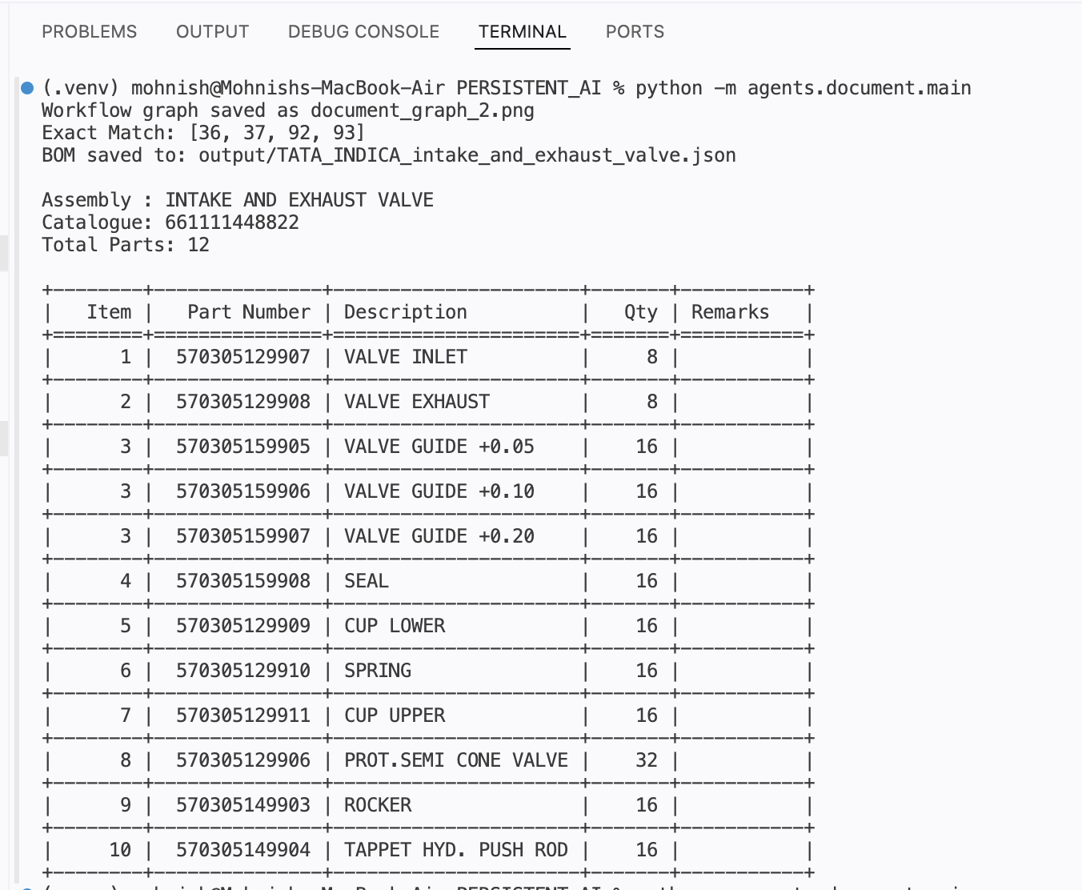
Figure 5: Terminal output of a full run — page match, saved file path, and the extracted BOM printed as a table.
The agent correctly matched pages [36, 37, 92, 93], saved the result to output/TATA_INDICA_intake_and_exhaust_valve.json, and reproduced all 12 rows from the source table, including the repeated item number “3” for the three Valve Guide size variants (+0.05, +0.10, +0.20), exactly as printed in the catalogue rather than being renumbered.

12. Catalogue Selection & Sample Outputs
Four real manufacturer catalogues were used for testing, chosen because they differ in layout, section density, and part-number style.
Catalogue | Sample Assembly Queried | Why Selected
Apollo Tractors | Wheel Drive | Clean, simple table layout — a good baseline case.
Mahindra Scorpio | Hand Brake (Group 2201A) | Index page shares space with multiple unrelated assemblies (wheel brake, instrument panel) — tests the “stop at next assembly” rule.
Mahindra Thar | Steering Gear and Mountings (Group 2101) | Has sub-item quantities inside description text and RF/NS remark codes — tests quantity and remarks handling.
Tata Indica | Intake and Exhaust Valve | Has a repeated item number (three “VALVE GUIDE” variants under item 3) — tests the “never renumber” rule.

This mix covers a tractor OEM, two Mahindra vehicles, and a Tata passenger car, so the rules tested here are not tuned to just one manufacturer's catalogue style.

12.1 Apollo Tractors — Wheel Drive
A clean 24-part extraction with sequential item numbers 1–24, consistent quantities, and no remarks needed.
Item | Part Number | Description | Qty
1 | M10130AA | Wheel Hub Rear-Big Double Tire | 4
2 | A55150AA | Tyre | 4
9 | D20500AA | Chain Sprocket | 4
13 | D10160AA | Chain | 4
24 | N55235AA | Spring Washer 12 mm | 48

Table excerpt: 5 of 24 extracted rows shown. Saved as: output/APOLLO_TRACTORS_wheel_drive.json

12.2 Mahindra Scorpio — Hand Brake (Group 2201A)
Extraction correctly stopped at the boundary of Group 2201A and did not pull in the neighbouring “Group 2202B — Wheel Brake” or “Group 2606A — Instrument Panel” sections, producing exactly 16 parts.
Item | Part Number | Description | Qty
1 | 0605AA0110N | Lever Parking Brake | 1
7 | 0605BA0120N | Assembly Frt Cable & Conduit HS | 1
14 | 56060A0010N | CBI SCR With SPL Washer M6 x 1 - 12 | 6
16 | 0068153 | Clip Wire | 2

Table excerpt: 4 of 16 extracted rows shown. Saved as: output/MAHINDRA_SCORPIO_hand_brake.json

12.3 Mahindra Thar — Steering Gear and Mountings (Group 2101)
The most complex case tested: item 8 (“Anti Squeak Steering Column”) had an unreadable quantity, correctly defaulted to 0 with the raw fragment kept in remarks instead of being guessed; item 19 correctly captured the “NS” (not supplied) code in remarks with quantity 0.
Item | Part Number | Description | Qty | Remarks
1 | 1106AAA01200N | Steering Wheel Assembly | 1
8 | 0080680 | Anti Squeak Steering Column | 0 | 24 x 11 3/4")
19 | SF0401012 | Washer Plain M8X16X1.5XZN5 | 0 | NS
26 | 1102AAA01490N | Steering Gear Assembly | 1

Table excerpt: 4 of 40 extracted rows shown. Saved as: output/MAHINDRA_THAR_steering_gear_and_mountings.json

12.4 Tata Indica — Intake and Exhaust Valve
Correctly preserved a repeated item number: item “3” appears three times for three Valve Guide size variants (+0.05, +0.10, +0.20), matching the catalogue's own numbering rather than being renumbered to 3, 4, 5. Full walkthrough and screenshots in Section 11.
Item | Part Number | Description | Qty
1 | 570305129907 | Valve Inlet | 8
3 | 570305159905 | Valve Guide +0.05 | 16
3 | 570305159906 | Valve Guide +0.10 | 16
3 | 570305159907 | Valve Guide +0.20 | 16

Table excerpt: 4 of 12 extracted rows shown. Saved as: output/TATA_INDICA_intake_and_exhaust_valve.json

13. Libraries Used & Their Purpose
Library | Role in the Document Agent
langgraph | Defines and runs the eight-step workflow that drives the whole pipeline.
langchain-openai (ChatOpenAI) | Client used to call the LLM for structured BOM extraction.
langchain-google-genai | Alternate LLM client integration available in nodes.py.
PyMuPDF (fitz) | Fast whole-document PDF opening and per-page text extraction for the page index.
pdfplumber | Text and table extraction on the small set of pages found to be relevant.
pydantic | Defines the BOMItem/BOM schemas and validates the LLM's output.
python-dotenv | Loads API keys and settings from a local .env file (llm.py).
tabulate | Prints the final BOM as a readable table in the console for quick checking.
difflib (stdlib) | Powers the fuzzy-matching fallback in page retrieval.
re (stdlib) | Used for keyword scoring and text cleanup.
json / pathlib (stdlib) | Parsing the LLM's JSON response and handling file paths for saving output.

14. Testing Methodology
Testing was done end-to-end rather than as isolated unit tests, since most failure modes come from how steps interact rather than from any one function on its own. For each catalogue, the process was:
- Run the full agent via DocumentAgent.invoke(pdf_path, query) on a real catalogue and a plain-language query.
- Check state["status"] and state["error"] at the end to confirm the run reached "saved" without failing earlier.
- Check the matched pages against the actual catalogue to confirm the right assembly section, and only that section, was picked.
- Open the saved BOM JSON and check every row against the source page: item numbers, part numbers, descriptions, quantities, and remarks.
- Re-run the same catalogue and query to confirm the output is stable, since temperature=0 is used on the LLM call.
This manual check was used because no ready-made “correct answer” dataset exists for these catalogues yet. It is also how the failure cases documented in Section 16 were found.

15. Challenges & Solutions
Challenge | Solution
Catalogues place multiple assemblies on the same or nearby pages, risking rows from the wrong assembly being pulled in. | A clear prompt rule tells the LLM to stop as soon as a different assembly title appears.
Some catalogue text has small variations or typos that break exact-phrase page matching. | Three-stage retrieval (exact → keyword → fuzzy match) so retrieval fails gracefully instead of breaking outright.
The LLM inconsistently returned item numbers as text or numbers, especially for values like “2-1”. | Every part's item field is converted to a string before schema validation.
The LLM sometimes added extra column codes (like effectivity letters) onto the description. | A dedicated rule in the prompt with a before/after example.
Quantity codes such as “RF” cannot be a number but should not be dropped. | The prompt sets quantity to 0 and keeps the code in remarks instead of guessing a number.
Extracted text sometimes has stray characters and extra whitespace that clutter descriptions. | clean_text() strips known noise and expands a fixed abbreviation list before the text reaches the LLM.
Making sure the LLM's JSON is well-formed before it is trusted or saved. | The prompt requires JSON only, and validate_bom runs full schema validation, failing clearly on any mismatch.

16. Limitations
The following limitations are noted honestly rather than glossed over:
- The rule of dropping the lowest matched page (assumed to be an index page) is a reasonable guess, not a guarantee — it can be wrong if the assembly genuinely starts on that page.
- There is no automatic retry if the LLM returns malformed JSON; a bad response currently causes a hard failure rather than a retry with a corrected prompt.
- There is no automated accuracy score yet — correctness is checked manually row by row (Section 14), which will not scale well as more catalogues are added.
- The agent runs in a single pass with no human review step before a BOM is saved as final.

17. Conclusion
The Document Agent completes the first step of the spare-parts pipeline: turning a PDF catalogue into a clean, validated Bill of Materials, saved as a JSON file, driven by a plain-language query with no manual page lookup needed. Its three-stage retrieval, rule-based prompt, and schema validation together produced correct, checked extractions across four different real catalogues covering tractor, SUV, and passenger-car assemblies.
This gives a solid, tested base for the rest of the pipeline. The BOM JSON schema defined here is exactly what the Inventory Agent will read once it is built, and the limitations listed above give a clear list of things to improve as more catalogues are added.

18. Future Work
The next milestone is the Vision Agent: a multimodal model that reads exploded-view diagrams directly and identifies parts and part numbers visually, to complement the Document Agent's text-based extraction for cases where key information is only clear in the diagram. After that, planned work includes:
- Vision Agent (next milestone) — extract parts from exploded-view diagrams and match them against the Document Agent's BOM for the same assembly.
- Inventory Agent — design the mock stock database and a lookup keyed on part_number against the BOM output.
- Decision Agent — decide the shortage threshold logic (fixed or per part category) once inventory data is available.
- Report Agent — generate a structured fulfilment report using the outputs of all agents.
- Document Agent improvements — an LLM retry step on JSON parse failure, an automated test set once a checked BOM dataset exists, and better handling of multi-column pages.
- The project's “creative agent” addition — to be planned once the core five-agent pipeline works end-to-end.

